ASIA AS SITE FOR CONTEMPORARY ART
RECENT INTERNATIONAL BIENNIALS AND TRIENNIALS
IN CHINA, KOREA AND JAPAN
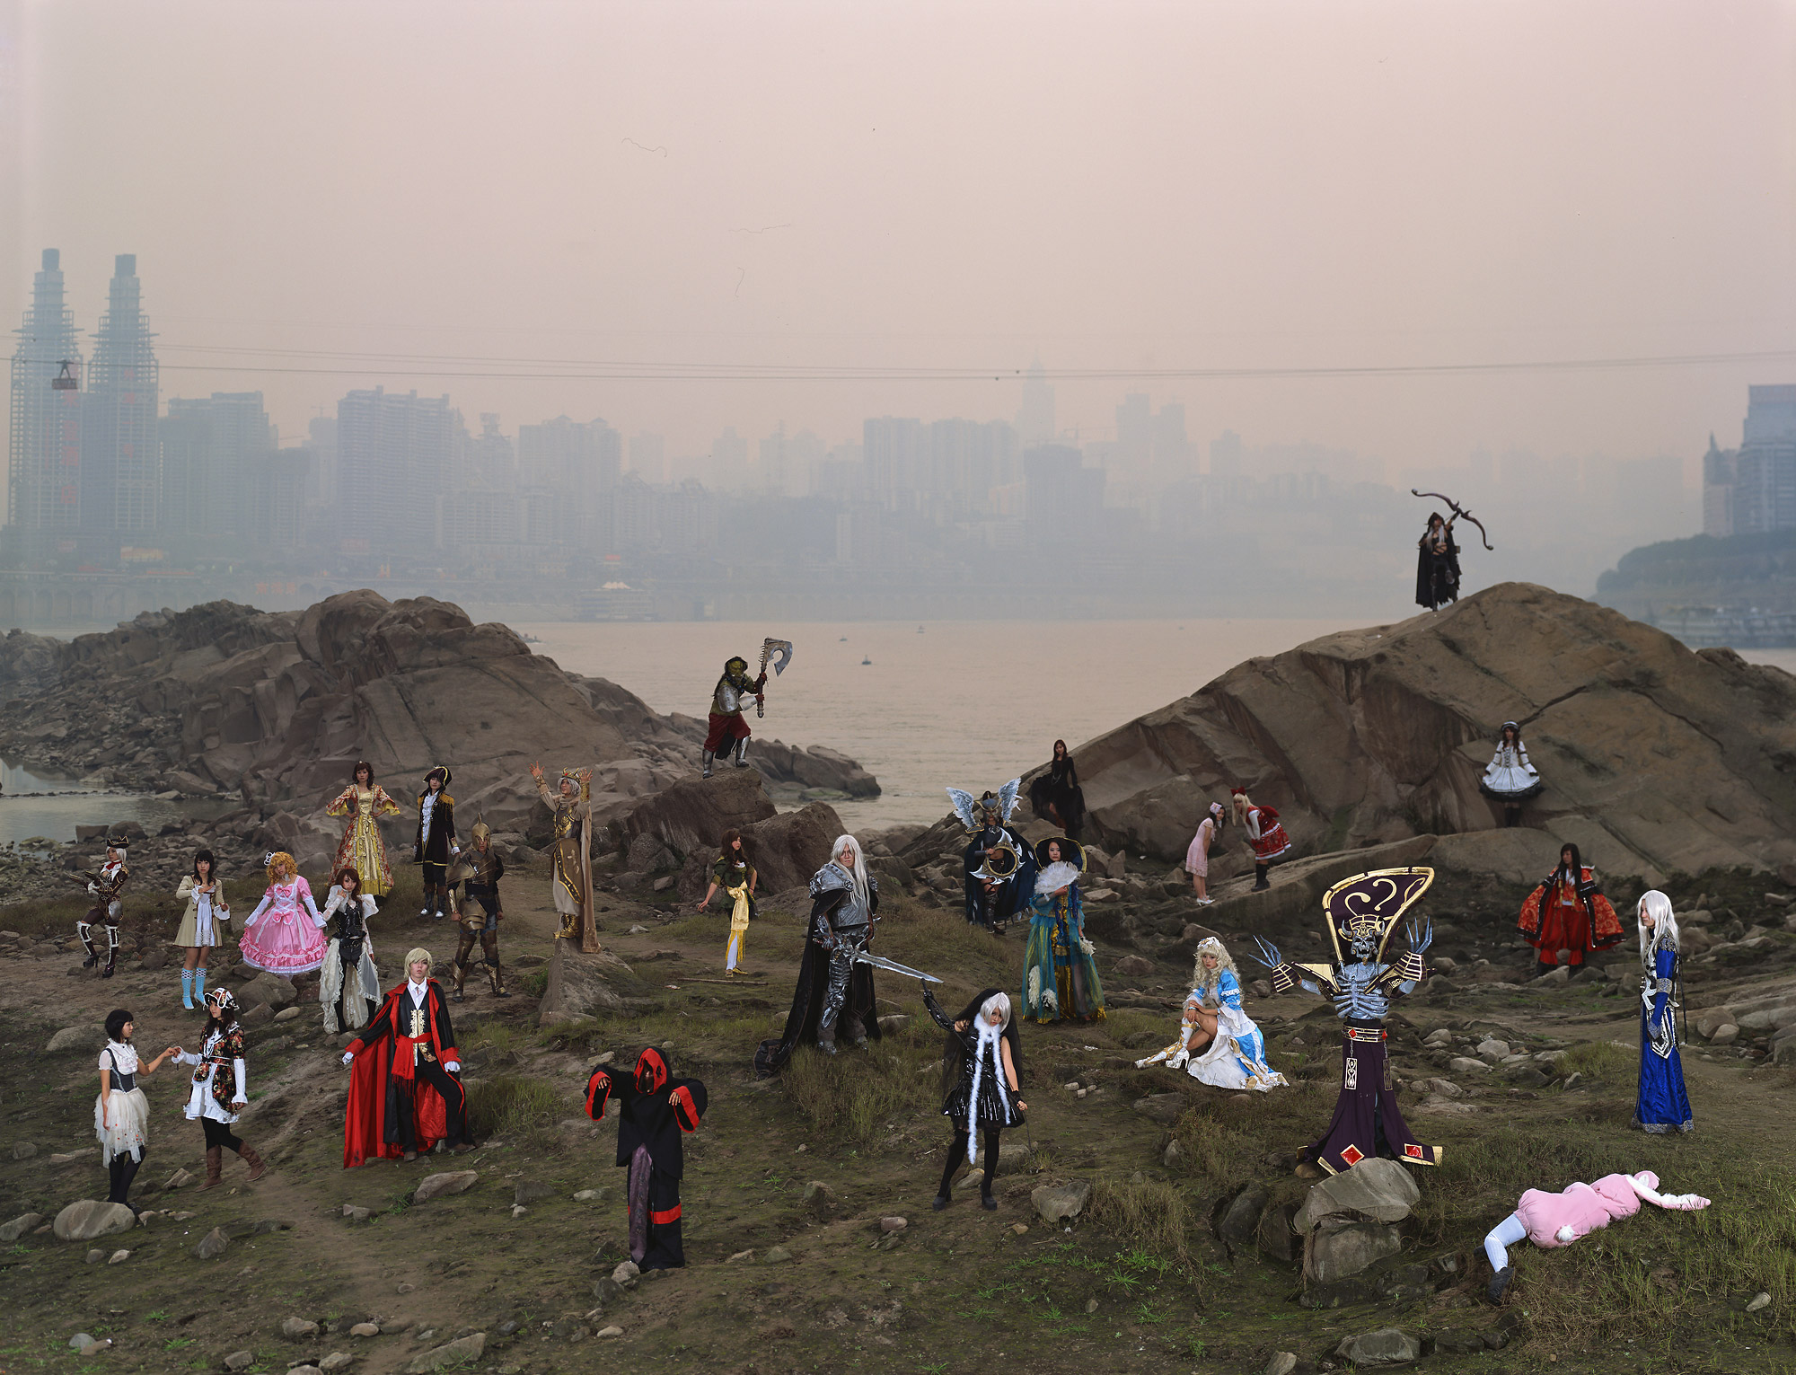

Zeng Han + Yang Changhong
World of Warcraft #01, Chongqing (2008)
Dimensions 60 inch x 78 inch
Chromogenic Prin
Following its prosperity as economic, political and technological force in the world, Asia has been proliferating large-scale international biennial and triennial art exhibitions in the last ten-year period. Such phenomena has not only introduced internationally reputed artists but also helped to emerge a new sense of cultural and artistic identity specific in each of the sites that have hosted such exhib itions, contributing to further development of contemporary art both in and beyond the sites in Asia.
In this presentation, Yasufumi Nakamori, Assistant Curator of Photography, will discuss the following five international biennial and triennial art exhibitions that opened this fall and he visited: Gwangju Biennale, Busan Biennial, Shanghai Biennale, Yokohama Triennale and Guangzhou Triennial. Refreshments will be served.
Wednesday, December 3, 6:30pm
American General Conference Room, Museum of Fine Arts, Houston
RSVP to eklim@mfah.org or 713.639.7594

