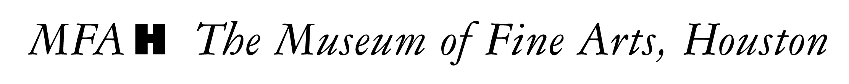

MEDIA ADVISORY CONTACT: MFAH PR
Friday, November 21, 2008 MFAHPR@mfah.org 713-639-7554

I Still Believe in Tomorrow: Contemporary Video from Asia Opens Monday, November 24, 2008, Showcasing Nine Contemporary East Asian Videos
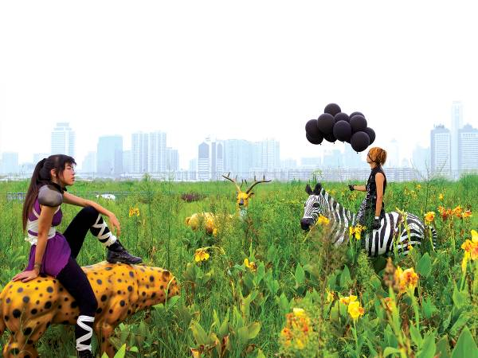

WHAT: I Still Believe in Tomorrow: Contemporary Video from Asia features videos created by five internationally acclaimed artists from China and Japan, who all reflect on East Asia’s rapid urban and cultural explosion in their work. Poignant, lyrical, and spellbinding, they confront the current conditions of urban life in their home countries, with the hope of changing the future. Nine single-channel videos will play on consecutive loop in the Brown Foundation galleries of the Audrey Jones Beck Building, on view through January 11, 2008. Interviews are available with MFAH Asian Art curator Christine Starkman and Assistant Photography curator Yasufumi Nakamori.

DETAILS: In three video works, Cao Fei (b. 1978) chronicles the lives of ordinary people caught in the modernization and development of communities in China, from teenagers engaging in cosplay (or “costume play”) to factory workers fantasizing about alternative careers. Jun Nguyen-Hatsushiba (b. 1968) plunges into the depths of the waters of Vietnam to create two memorial videos for those displaced from their homeland because of the Vietnam War. Yang Fudong (b. 1971) uses his friends to depict the fable of unruly Taoists who withdrew from public life, following in the footsteps of artists and writers throughout the centuries who emulated the legendary Taoists’ lifestyle. Videos by Sawa Hiraki (b. 1977) explore time and space travel beyond the boundaries of his tiny London apartment, addressing feelings of dislocation and hope, and Shimabuku (b. 1969) investigates the world by taking an octopus on a tour of Tokyo, effectively creating his own folklore.

INTERVIEW
OPPS: Christine Starkman, Asian Art curator
Yasufumi Nakamori, Assistant Curator, Photography Department

WHEN: By appointment, to be scheduled through the MFAH’s PR office.
WHERE: Museum of Fine Arts, Houston, Audrey Jones Beck Building, 5601 Main St
MORE: The museum’s dedication to Asian art was solidified in 2000 with the appointment of Christine Starkman as curator of Asian Art. I Still Believe in Tomorrow coincides with the museum’s installation of five permanent Arts of Asia galleries (including the Indonesian Gold gallery opening December 5, 2008), and the exhibition offers a sneak peek of Japanese artist Shimabuku’s video work, which will be on permanent display in the Arts of Japan gallery (slated to open in the winter of 2010). Also upcoming at the MFAH are a number of exhibitions focusing on Asian art, including Art Unfolded: The Gift of Conservation from Japan (January 17, 2009), Arts of Ancient Viet Nam: From River Plain to Open Sea (September 13, 2009), and Contemporary Korean Photographs (October 18, 2009), amongst others.

